|  |
| --- |
| BSHC3, BSHCE3, BSHBIS3, BSHBISE3, BSHTM3 |
| Requirements Specification (RS) |
| Golden Years |

|  |
| --- |
| Jessica Banoke, Angela Darel, Keith Feeney, Charlene Moore  14 October 2017 |

Requirements Specification (RS)

Document Control

Revision History

|  |  |  |  |  |  |
| --- | --- | --- | --- | --- | --- |
| **Date** | **Version** | **Scope of Activity** | **Prepared** | **Reviewed** | **Approved** |
| 14/10/2005 | 1 | Create | AB | X | X |
| 21/10/05 | 2 | Update | CD |  |  |

Distribution List

|  |  |  |
| --- | --- | --- |
| **Name** | **Title** | **Version** |
| Manuel Tova-Izquierdo | Lecturer |  |
|  |  |  |
|  |  |  |
|  |  |  |
|  |  |  |

Related Documents

|  |  |
| --- | --- |
| **Title** | **Comments** |
| Title of Use Case Model |  |
| Title of Use Case Description |  |

**Table of Contents**

Requirements Specification (RS) 1

Document Control 1

Revision History 1

Distribution List 1

Related Documents 1

1 Introduction 5

1.1 Purpose 5

1.2 Project Scope 5

1.3 Definitions, Acronyms, and Abbreviations 5

2 User Requirements Definition 6

3 Requirements Specification 6

3.1 Functional requirements 6

3.1.1 Use Case Diagram 6

3.1.2 Requirement 1: Populate Event 7

3.1.3 Requirement 2: Search Events 11

3.1.4 Requirement 3: Book event 13

3.1.5 Requirement 4: Create Customer Account 16

3.1.6 Requirement 5: Create Business Account 18

3.2 Non-Functional Requirements 20

3.3 Performance/Response time requirement 20

3.4 Availability requirement 21

3.5 Recovery requirement 21

3.6 Robustness requirement 21

3.7 Security requirement 21

3.8 Reliability requirement 22

3.9 Maintainability requirement 22

3.10 Portability requirement 22

3.11 Usability requirement 22

3.12 Reusability requirement 22

4 GUI 23

5 System Architecture 24

6 System Evolution 25

7 References 25

# Introduction

## Purpose

After consultation with the Client, the purpose of this Project is to create a Web Application that specialises in providing event details to a member of the public (Customer). Additional menus can also be added. In the Project, “Medical” and “Golden University” are examples of such menus. The Customer can create and book an event from the Application.

The intended target is people over the age of 65 (old-age pensioners / OAPs), but anyone can use it. For example, an OAP might have a son who uses the Application to book events for his mother.

## Project Scope

The scope of this Project is to create an Application that is targeted for OAPs who wish to search and book events. The System shall be connected to the Internet and connected to a private Database System.

The Group were in talks with Mary Smith from Web Solutions Ltd. To elicit the following requirements:

* Must be able to search and book events
* Must be able to accept card payments.
* Must be able to create Customer and Business accounts.
* Must be able to create other menus.
* Must be completed in 13 weeks.
* Budget: €18,200 (€350 per person per week)
* Future proof

## Definitions, Acronyms, and Abbreviations

Customer – Defines as a member of the public using the Application, whether they have an account or not (Customer or Guest)

Business – defines the many businesses that will be adding their events to the Application.

……..

# User Requirements Definition

The client has requested a Web Application that they wish to use on touch screens in public areas, such as O’Connell Street.

They have requested that the Web Application target is for people over the age of 65, but that anybody can use the Application.

The client has specified that the Web Application is for creating and booking events, but has the capabilities of any other sections such as Medical advice or Education.

# Requirements Specification

An Admin must have an understanding of Privacy and Security. Admins must have a basic computing knowledge, specialising in the Windows OS. Training will be provided to Admins, that will not exceed one hour.

## Functional requirements

### Use Case Diagram

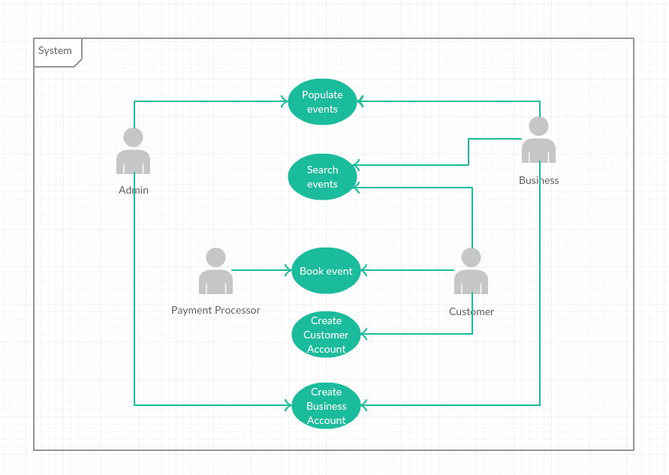

### Requirement 1: Populate Event

This is where a Business can add an Event so that users can select one.

#### Description & Priority

This is a vital part of the Web Application. These Events will be added by the Business so that a Customer can select them and book them. Without this requirement, the application would not work.

#### Use Case

Populate Event

**Scope**

The scope of this use case is to for a Business to create Events on the Web Application. When created, the Business can create a new Event or edit their own Events or view other public Events that have been previously added and approved.

**Description**

This use case describes how a Business can add an Event by inputting relevant data into text fields, or selecting the likes of a calendar and time drop-down menu. All new Events must be validated by an Admin (for likes of payment, profanity, etc.).

**Flow Description**

**Precondition**

* Admins must approve new events before they are live on the Web Application.
* Admins are always logged in
* Admins must check new Events for profanity, errors and misspellings and/or confirm changes with Business.
* Business have previously created an account.
* The communication between the Server/Internet and the Web Application must be connected (via mobile Wi-Fi).
* If required, the Server and Web Application need to have the latest updates.
* When an Event is “live”, this means that the event is public for the Customer.
* Many pages exist within the app
* A Database stores the events.

**Activation**

This use case starts when a Business wishes to sign in to their previously created account and create a new event.

**Main flow**

1. The System is currently in a wait state on the Main Page, waiting for a button to be tapped. The buttons are; “Log in/Sign up”, “Continue as Guest” and “Business Log in/Sign up”.
2. The Business selects “Business Log in/Sign up”.
3. The Business enters in their username and password.
4. System displays buttons “Create new event”, “Edit event” and “Search live events”
5. The Business selects “Create new event”.
6. System displays “New event page”. The page contains text boxes for the Business to input data.
7. The Business inputs the title.
8. The Business selects how many places are available. If left blank, it’s unlimited.
9. The Business inputs the Price of the Event.
10. The Business selects whether payment can be made at Event. (Yes/No)
11. The Business enters Price
12. The Business inputs the address.
13. The Business checks the Google Maps marker and edits it if necessary.
14. The Business inputs the phone number and/or email for event enquires.
15. The Business selects a date from a calendar.
16. The Business selects a time from a drop-down menu.
17. The Business selects whether Transport is included (Yes/No option)
18. <See A1>
19. The Business selects “No” option.
20. The Business selects Save. <See E1>
21. System sends data to Database on the server.
22. System displays message “Your Event has been received and will be checked by an admin before going live”.
23. The Business can log out or browse their own events or other public events.
24. Admin receives notification there’s a new event.
25. Admin checks event for profanity, spelling errors, etc.
26. Admin checks for payment from Business (outside System)
27. Admin approves Event provided there’s payment (outside system).
28. Event is live.

**Alternate flow**

A1 : Transport selection is “Yes”

12. The Business inputs Transport company.

13. The Business inputs pickup location and time.

14. The Business inputs drop-off location (if different from event)

15. The Business inputs return pickup location (if different from event) and time.

16. The Business inputs return drop off (if different from original pick up location).

17. <Returns to Step 13 in Main flow>

**Exceptional flow**

E1 : Network connection lost when Business is creating Event

1. The System is unable to connect to the Server or the Internet due to (e.g.) Server being upgraded.
2. The System saves the current page and the inputs from the Business.
3. The System send an email to Admin with error message.
4. Business is logged out by System.
5. Network connectivity returns.
6. Business logs back in.
7. System displays the page the Business was on.
8. <Returns to Step 12 in Main Flow>

**Termination**

This use case is terminated when the Admin has posted the Event.

**Post condition**

The system goes into a wait state and is ready for input, or for the Admin or Business to sign out of their account.

### Requirement 2: Search Events

#### Description & Priority

Search Events is where a Customer can search for events within the Web Application. This is a very important part of the Application, as without it, Customers would not be able to proceed to booking events.

#### Use Case

Search Events

**Scope**

The scope of this use case is allow Customers to search for events by searching via text and Google Maps. When the Customer selects an Event they wish to attend, the use case ends.

**Description**

This use case describes the how the Customer will input text and/or select a location from Google Maps. Nearby events will show on the map for the Customer to select.

**Flow Description**

**Precondition**

* The Customer is logged in
* Guest account is defined as a Customer. Guest accounts are given the username “Guest” followed by a random, unique number, e.g. Guest5256
* The network connectivity between the Web Application and the Server and/or Internet is connected.
* The user’s location is pre-set
* “Search page” is where the System shows the following buttons: “Search events” and “Your events”. Other buttons are present but not important for this Use Case.
* “Maps page” is where an embedded, interactive Google Maps map with markers or nearby events is shown along with a short list of the most popular apps.
* “Event page” is where information about an Event is shown for the Customer. It also contains “Return” and “Book” buttons.
* It is assumed that the Customer can only book one Event per booking or “transaction”.

**Activation**

This use case starts when a Customer taps “Search Events” within the Application.

**Main flow**

1. The System identifies that the Customer is logged in and that the network remains connected.
2. System displays buttons on “Search page”.
3. The Customer taps “Search events”.
4. The System changes page to “Maps page”. <See E1>
5. Customer selects an event from the list or select a marker on the map.
6. System shows Event Page.

<See A1>

1. Customer selects “Book”. Customer has successfully searched for an event

**Alternate flow**

A1 : Customer does not like Event, searches for another one.

1. The Customer selects “Return”

<Returns to Step 5 in Main Flow”

**Exceptional flow**

E1 : Google Maps server down

1. System displays message “Cannot connect to Google Maps”.
2. System removes Map and gives list of local towns/cities.
3. System keeps checking for Google Maps connection

<Returns to Step 5 in Main Flow>

**Termination**

When the Customer selects “Book”, this Use Case ends.

**Post condition**

The System waits for Customer input.

### Requirement 3: Book event

#### Description & Priority

Book Event is where a Customer books an Event. Depending on whether it’s free or not, the Customer may need to input their credit card information. This Use Case is not essential, but it would be very useful when implemented.

#### Use Case

Book Events

**Scope**

The scope of this use case allow Customers to book an event and go through the process of paying for it if requested.

**Description**

This use case describes the how the Customer will confirm a booking and input their credit card information if needed. It also describes how the communication between the credit card company and the System. A text/email confirmation message will be sent to the Customer on completion.

**Flow Description**

**Precondition**

* The Customer is logged in.
* Guest account is defined as a Customer. Guest accounts are given the username “Guest” followed by a random, unique number, e.g. Guest5256
* The network connectivity between the Web Application and the Server and/or Internet is connected.
* “Event page” is where information about an Event is shown for the Customer. It also contains “Return” and “Book” buttons.
* It is assumed that the Customer can only book one Event per booking or “transaction”.
* The Customer is on the Booking page and has previously searched for an event they would like.
* Payment Processor is the company/service that deals with actually accepting the payment.
* End Page is where the booking is complete. It lists the confirmed booking. The Customer can log out or review the booking.

**Activation**

This use case starts when a Customer taps “Book” on the Events Page.

**Main flow**

1. The System identifies that the Customer has tapped the “Book” button.
2. System shows Booking Page
3. System lists event and price.

<See A1 & A2>

1. Customer enters Credit Card information into respective fields.
2. Customer selects “Continue”.
3. System sends credit card information to Payment Processor

<See A3 & E1>

1. Payment Processor confirms payment.
2. System sends confirmation to Customer’s email or via SMS.
3. System shows End Page.
4. If no input from user within 60 seconds, the System logs the user out.

**Alternate flow**

A1 : Event is free.

1. System hides Credit Card information input boxes.

<Returns to Step 8 in Main Flow>

A2 : Business has selected that user can pay at the Event.

1. System displays message “Would you like to pay at the Event?”
2. If no -> Returns to Step 5 in Main Flow
3. If yes -> Returns to Step 8 in Main Flow

(Note, this would be hidden if Business does not allow Customers to pay at the Event)

A3 : Payment Processor declines card..

1. Payment Processor declines payment
2. System displays message: “Your payment has been declined”
3. Customer selects OK.

<Returns to Step 3 in Main Flow>

**Exceptional flow**

E1 : Payment Processor cannot be reached (e.g. Server down)

1. System displays message “Cannot process your payment. Please try again later.”

<Returns to Step 5 in Main Flow>

**Termination**

When the Customer logs out or is logged out by the System, this Use Case Ends.

**Post condition**

The System returns to the Main Page and waits for input.

### Requirement 4: Create Customer Account

#### Description & Priority

Customer account is where a Customer can create an account. It is not necessary for a Customer to create an account, but it is a useful tool.

#### Use Case

Create Customer Account

**Scope**

The scope of this use case allow Customers to create an account.

**Description**

This use case describes the how the Customer is able to create an account. If the Customer is a Guest, they can create an account from any page, e.g. Events Page, Booking Page, etc.

**Flow Description**

**Precondition**

* The network/Internet is connected.
* Create Customer Account page is a page where a Customer can input their information.

**Activation**

This use case stars when a Customer selects “Sign up” from the main page.

**Main flow**

<See A1>

1. Customer selects “Sign up” from the Main Page.
2. System displays “Create Customer Account” page.
3. Customer inputs their name (required)
4. Customer inputs their address, city
5. Customer inputs their email and/or phone number (one required)
6. Customer selects “Save”
7. System sends data to database.

<See E1>

1. System sends password and confirmation to Customer’s email and/or phone.

**Alternate flow**

A1 : Customer is a Guest and wishes to create an account from any page.

1. Customer selects “Sign up”.
2. System saves current page in current state.
3. System displays “Create Customer Account” page

<Returns to Step 3 in Main Flow>

1. System displays saved current page.
2. System deletes saved page from memory.

**Exceptional flow**

E1 : System cannot communicate with Database.

1. System displays message “Sorry, an error occurred!”
2. Customer clicks “OK”.
3. System returns to Main Page. (Account cannot be created)

**Termination**

When the Customer has created an account, this Use Case ends.

**Post condition**

The System waits for input.

### Requirement 5: Create Business Account

#### Description & Priority

Business account is where a Business can create an account. If a Business wishes to create an Event, a Business Account is required.

#### Use Case

Create Business Account

**Scope**

The Scope of this Use Case is to allow a Business to create an account, so that they can Create Events or Search live events.

**Description**

This use case describes the how the Business is able to create an account. All Business Account creations need to be approved by an Admin, for security and permission security.

**Flow Description**

**Precondition**

* The network/Internet is connected.
* Create Customer Account page is a page where a Customer can input their information.
* Admins must approve new Business Account
* Admins are always logged in
* A Business Account must be created from the Main Page and cannot be accessed when logged in as a Customer (or Guest)
* Business Sign Up Page is where a Business inputs their information. This is different from a Create Customer Account Page.

**Activation**

This use case stars when a Business selects “Business Sign Up”.

**Main flow**

1. Business selects “Business Sign Up”
2. Business inputs Company Name
3. Business inputs Representative’s name
4. Business inputs Representative’s email and/or phone number
5. Business selects Save

<See E1>

1. System sends data to Database.

<See A1>

1. Admin approves Business Account
2. System sends password and confirmation to Business’s email and/or phone.

**Alternate flow**

A1 : Admin does not approve Business Account.

1. Admin does not approve Business Account
2. System sends email/SMS to Business to inform that their Business Account was not created.

**Exceptional flow**

E1 : System cannot communicate with Database.

1. System displays message “Sorry, an error occurred!”
2. Business clicks “OK”.
3. System returns to Main Page. (Account cannot be created)

**Termination**

When the System sends communication to the Business, this Use Case Ends.

**Post condition**

The System returns to the Main Page and waits for input.

## Non-Functional Requirements

## Performance/Response time requirement

There are no standards for response time, therefore Golden Years should response within 300-500ms (Stack Overflow, 2017). Ideal page response/ loading time would be 200-300ms but 500 is still acceptable for the purpose of the project

## Availability requirement

Application run time would be 24h, also booking system would run 24h. As application presents users with both- events information and booking system, it should be available throughout bank holidays and any other holidays.

Golden Years should be available to access from any device, connected to the internet with wire or via **Wi-Fi**.

## Recovery requirement

Recovery time after a downtime, shouldn’t be longer than 24 hours. Maximum accepted offline time - RTO (recovery time objectives) shouldn’t pass 48h. RPO (recovery point objective) ideal time shouldn’t pass 8h, as this would be the maximum accepted time when data can be lost from Golden Years (Cloud Google, 2017).

Backup for inserted transaction data should be every 5 minutes since the payment information is sensitive and will also rely on payment systems such as bank or **PayPal**.

Recovery and availability requirement are connected in terms of creating **backup** server and creating back up data, to ensure fluent run of the server in the case of major disaster such as system down, power down etc.

# 

## Robustness requirement

Listener should reject API requests, that are invalid.

Unexpected flood of requests (happen due to errors or attack), should be resisted by listener.

Listener or database sessions shouldn’t be able to create amount of processes exceeding or reaching maximum session limit. It should limit them instead.

Application should terminate and provide error message whether an error occurred (i.e. lack of connection to database) or application is not available (i.e. due to chosen payment method issues – bank application maintenance).

Database should be protected from reaching session limit.

## Security requirement

Security of application should be incorporated into **its** developing process. Good authentication process (possibly tied to user ID and/or IP), encrypting and backing data and databases, access protection for data and databases, right handling of the session etc. Login and password should be encrypted, same as sensitive data such payments. Timeout message should pop up on the screen after 5 minutes of user inactivity. There should be confirmation timeout button, so the user is aware and can log back in before performing another action.

## Reliability requirement

In order to provide reliability of the application:

* Time between application failures should not exceed 1 per 6 months.
* Components failure should not occur more than 1 per 6 months.
* Possible errors inducted by maintenance of the system, should not exceed 2 per year

## Maintainability requirement

Golden Yeas will go through testing faze before launching. Testing would ensure discovery and elimination of possibly occurring errors (errors can occur in design, code or logic level of application).

Support after the launch would be handled by both the Support Team and the Development Team for a period of 1 month, to allow for a fast response and fixing of any core issues. After that period support queries should be handled solely by the Support Team.

## Portability requirement

Golden Years is an online based application. Therefore, it requires an internet connection to ensure proper functioning. It's not a standalone application and can' be for example downloaded and stored (i.e. on USB drive).

## Usability requirement

As special purpose application, that is to server senior users, the application should have clear and simple interface. Also, to ensure clear view and ease of the usage, Golden Years content should be presented with bigger than standard font size and contain big, easy to see and click buttons.

## Reusability requirement

Golden Years team have not created any similar project, there are no component that can be reused in the development of the application. However, the use and modification of pre-existing web application components templates is considered.

# GUI

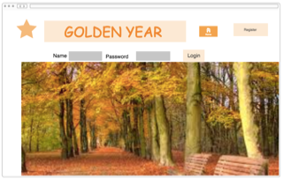



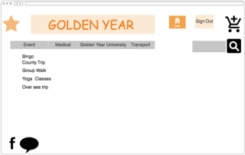

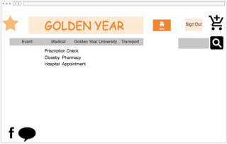

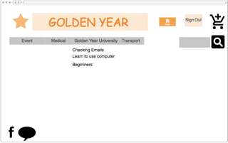



# System Architecture

Use a class diagram to outline the structure of the system. Explain briefly why you have chosen this architecture. You might want to use Visio or Rational Rose to create these.

# System Evolution

Idea 1: The System could be evolved to be just a Web Site instead of a Web Application. If the touch screens in public areas was not to work, it could become a website so that anyone, anywhere could use it, not just the people standing in public areas.

Idea 2: The System could be transformed into a mobile application. It would be easy to use and could introduce OAPs to the world of technology.

Idea 2a: Because Virtual Reality is becoming popular. The System could incorporate Virtual Reality (VR) headsets with the mobile app. For example, instead of having to go to the location of an event. The event could be started in VR. The OAPs would are not as mobile could see attend events.

# References

performance - Is there some industry standard for unacceptable webapp response time? - Stack Overflow. 2017. *performance - Is there some industry standard for unacceptable webapp response time? - Stack Overflow*. [ONLINE] Available at: <https://stackoverflow.com/questions/184814/is-there-some-industry-standard-for-unacceptable-webapp-response-time>. [Accessed 03 October 2017].

Thoughts from the Systems front line..... 2017. *A Basic Non-Functional Requirements Checklist « Thoughts from the Systems front line....*. [ONLINE] Available at: <https://dalbanger.wordpress.com/2014/01/08/a-basic-non-functional-requirements-checklist/>. [Accessed 04 October 2017]

Google Cloud Platform. 2017. *How to Design a Disaster Recovery Plan  |  Solutions  |  Google Cloud Platform*. [ONLINE] Available at: <https://cloud.google.com/solutions/designing-a-disaster-recovery-plan>. [Accessed 04 October 2017]